<https://bohanhyland.ie/wp-content/uploads/2019/02/logo-outline.png>

<https://bohanhyland.ie/>

Power outage ESB:

<https://powercheck.esbnetworks.ie/>

The idea for this project came from my partner, he works in a property management company called Bohan Hyland (<https://bohanhyland.ie/>), the bock and facility management section is the department that he works and he gave some suggestions of functions that would help him and his team. Some of these suggestions are:

* A page where the registered user would be able to order keys and fobs

He informed that their website needed to be improved. It was not updated for at least 10 years and the “bock and facility management section” section would benefit them if there was a member area where members could log in and order new keys and fobs. At the moment these orders are made via email and his idea was to have a shopping cart on the website.

Here was one of their competitors he mentioned as an example of good layout: <https://www.owenreilly.ie/>

Requirements:

* Improve their website, making it looking more modern
* Remove the box around their logo
* Include a “member portal” section to the “OMC Block Management” section

After hearing the ideas, my first step was to create the html pages that I knew we would need and start from them. More pages to be added later if necessary. These are the pages:

1. Home Page (index.html)
2. About Us
3. Members Portal
   * Register
   * Login
   * Order
4. Contact Us (contact.html)
5. Services
   * Residential Sales
   * Lettings

Navigation Bar

* I followed the “Navbar Bootstrap 5 | Bootstrap Navbar Tutorial” (link in the reference section) to create a nav bar using bootstrap, including the drop-down in the nav bar
* The color rgb(33,67,156) is the color of the logo background color. I used the color picker using inspector in chrome. After I got the rgb equivalent, I added **style="background-color:rgb(33, 67, 156)** to the nav tag
* I used the Bootstrap dropdown option

Contact Page (contact.html)

* I decided to use the Modal bootstrap button, as it opens a confirmation pop-up window once the message is sent. It has a nice layout. I made the necessary changes to work the way I wanted
  + I removed the “save changes” button
  + I used the **class="btn btn-primary"** for the close button
  + Added “required” to the forms inputs to make the fields mandatory
* **“modal”** code from Bootstrap looks better than the traditional **onclick="myFunction()"**
* The video “10 Form Validation Tips Every Web Developer SHOULD KNOW!” helped me to implement some form validation. Link to the video can be found in the reference section
  + Name input field has type="text" and regex to allow letters and empty space only. **^[A-Za-z\s]+$**
  + Password input field type and id modified. type="password" id="password"
  + I’ve added min and max length to the fields

Login page (login.html)

* This is a copy of Contact Us page with some modifications
* Password type=” password”
* pattern="/.*[0-9]./" added to the input field to make sure the field only accepts numbers

For styling, I decided to user Bootstrap. The focus of this project is JavaScript, using bootstrap for layout would allow me to create a layout quickly to be used on all pages without the need to have a .css file on my project. To use Bootstrap, I added the two lines below to my page headers, as per instructed on the bootstrap page:

<link href="https://cdn.jsdelivr.net/npm/bootstrap@5.3.3/dist/css/bootstrap.min.css" rel="stylesheet" integrity="sha384-QWTKZyjpPEjISv5WaRU9OFeRpok6YctnYmDr5pNlyT2bRjXh0JMhjY6hW+ALEwIH" crossorigin="anonymous">

<script src="https://cdn.jsdelivr.net/npm/bootstrap@5.3.3/dist/js/bootstrap.bundle.min.js" integrity="sha384-YvpcrYf0tY3lHB60NNkmXc5s9fDVZLESaAA55NDzOxhy9GkcIdslK1eN7N6jIeHz" crossorigin="anonymous"></script>

Bring to the top button:

I tried to add an icon to bring the page to the top but it did not work, this was my attempt to troubleshoot the issue:

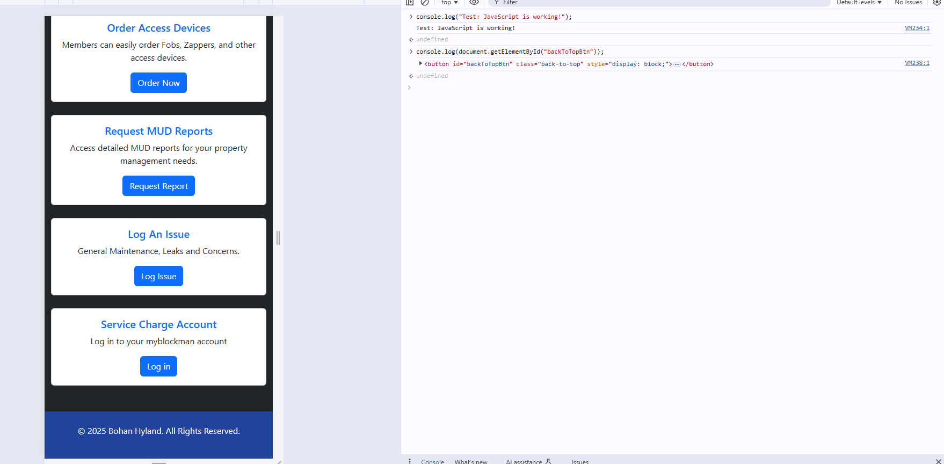

The button appeared after I trigged it manually in the webconsole by running this command:

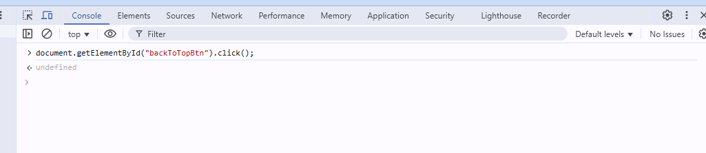

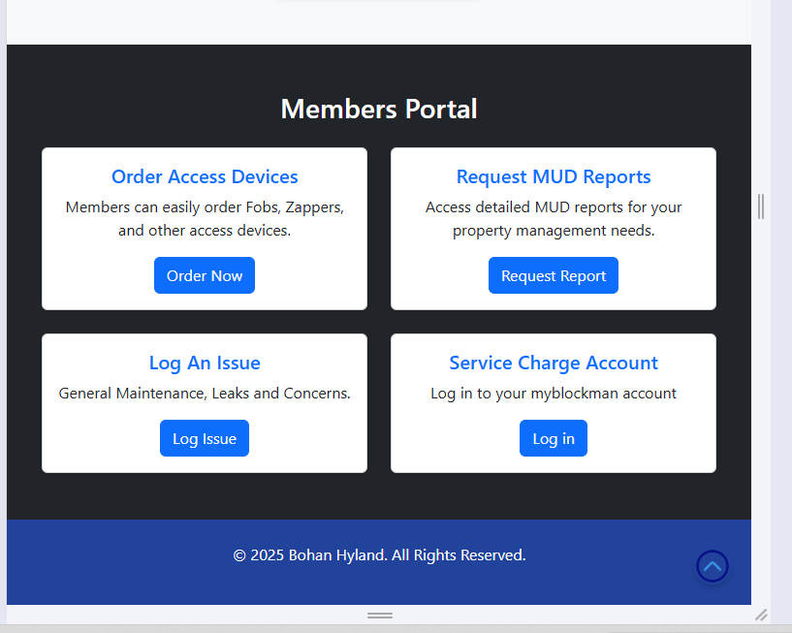

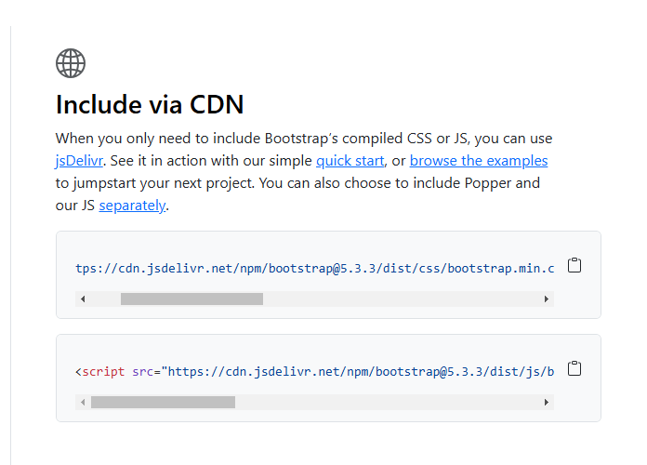

Github

Repository: <https://github.com/gustavowmarques/bohanhyland.git>

Issues:

I had issues committing new changes from visual studio

I was committing and pushing a change and I noticed that “master” branches were being created:

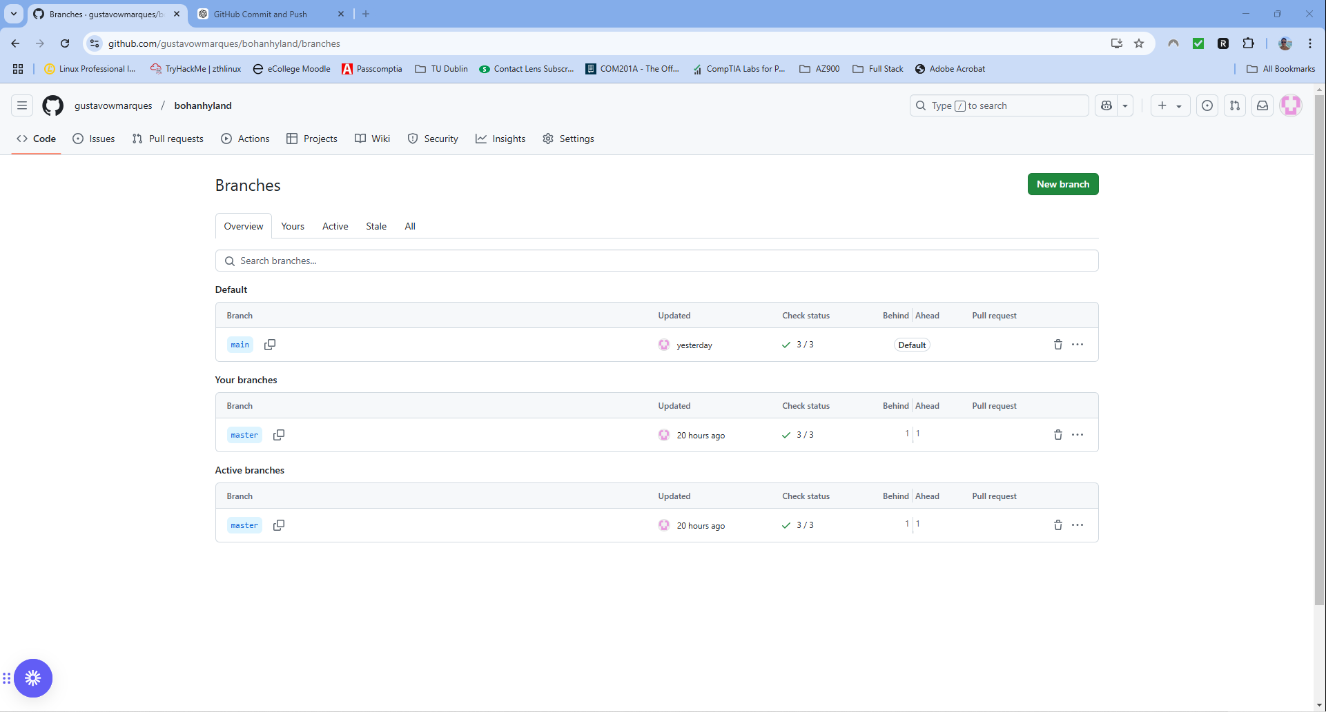

I used Chat GPT to help me to merge everything into 1 branch and delete the others.

Everything is now within the branch named “main”

I also had issues with the Mortgage Calculator, after following the steps from the “Mortgage loan calculator with JavaScript” tutorial (link in the references), I entered the values, pressed the “calculate” button but nothing was happening.

I also noticed that the footer was not showing up fully:

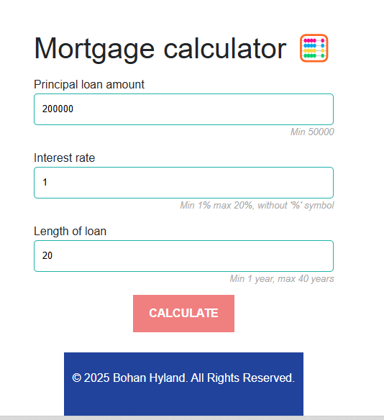

I reviewed the script.js file and made these changes:

* I noticed that I had two “document.addEventListener("DOMContentLoaded", function () {“ in that document. The first one at the start of the file and the second one before the “back to the top” script:
  + 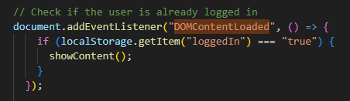
  + 

This what I did to fix the calculation issue:

* Merged both DOMContentLoaded listeners into one
* Ensured all elements are properly checked before adding event listeners.

After fixing the mortgage calculation issue, two new issues appeared:

1. The navigation bar is no longer showing up
   * 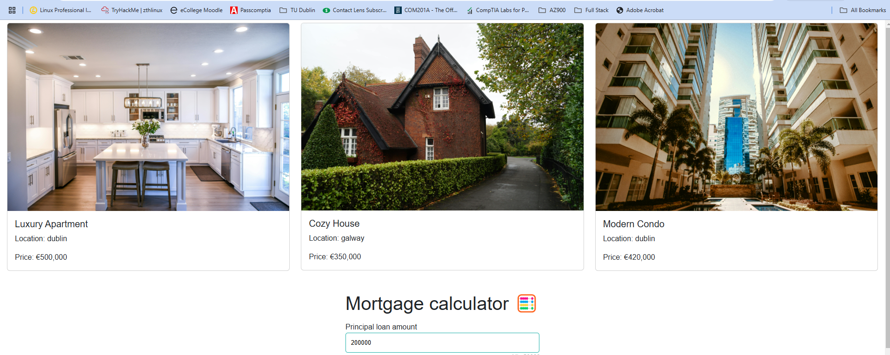

The navigation bar still doesn’t show up. When I refresh the page, I see the nav bar quickly, it shows up in a smaller/mobile version and disappear quickly

I suspect the issue is due to the javascript or css file because these were the files I updated after adding the mortgage calculator

* + Inspector shows that the navbar is found
  + 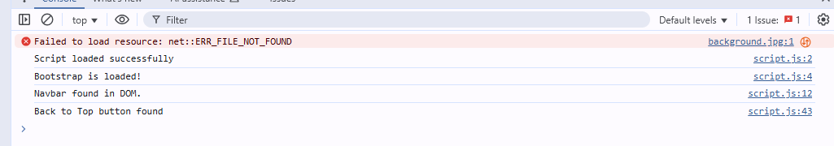
  + The issue with the navbar is with the CSS code added from the mortage calculator code (<https://dev.to/bosspetta/mortgage-loan-calculator-with-javascript-2la7>). I commented the code and the navbar was back:
  + 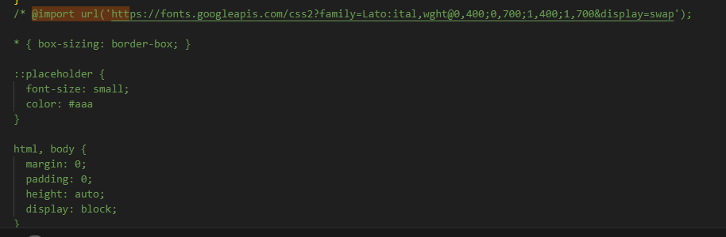
  + 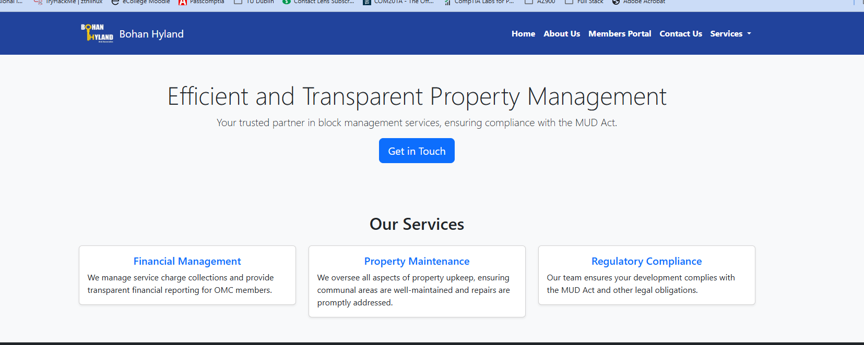
  + There is something in the new code that is hiding the navbar
  + I started to comment out the css code that was causing the problem block by block and I noticed this part of the code was hiding the nav bar:
  + 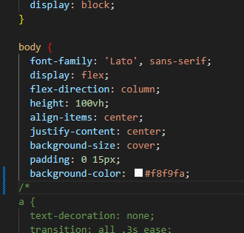
  + The “display: flex;” was hiding the navbar but when commented out, it was making the Mortgage calculator box to be too big:
  + 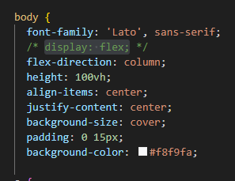
  + 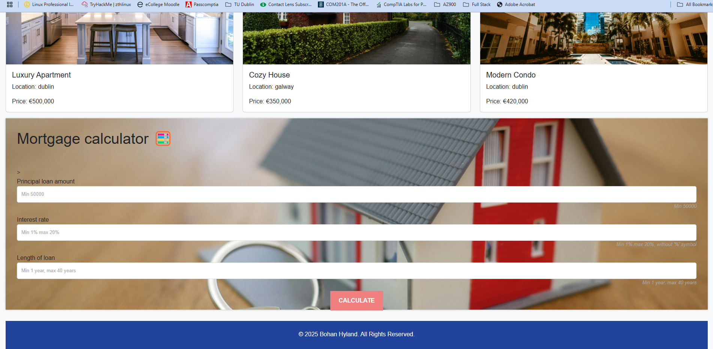
  + I Used bootstrap grid col classes for responsive behaviour and to ensure that the container adapts based on the screen width.
  + Ensured that the form is wrapped in a responsive container that scales on small screens.
  + The form should stay vertically centered even on small screens.

1. The footer on the residential sales page was not responsive to the display size. It is was showing up small even on large screens.

To fix this issue, this is what I did:

* + The display: flex; flex-direction: column; align-items: center; justify-content: center; in body is centering all content, making the footer smaller than expected.
  + This is what I added to the style.css file to ensure the footer remains at the bottom even on larger screens:
    - padding: 20px 0;
    - width: 100%;
    - position: relative;
    - bottom: 0;

Lettings.html stopped loading properly

* After reviewing the pages, I noticed that lettings.html was no longer displaying the properties
* Using the Chrome inspector and loading the page, I noticed the error:   
  “script.js:174 Error: One or more mortgage calculator elements are missing in the DOM!”

﻿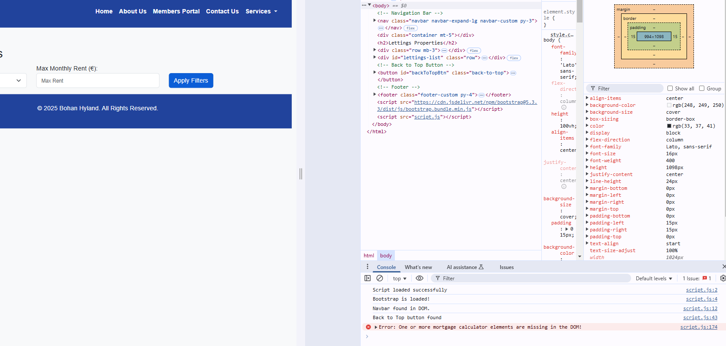

* Error shows line 174 in the script.js file
* I reviewed the script.js file on that line mentioned and I noticed that the “else” was misplaced. This was due a missing curly bracket
* After fixing this, the page loaded correctly
* 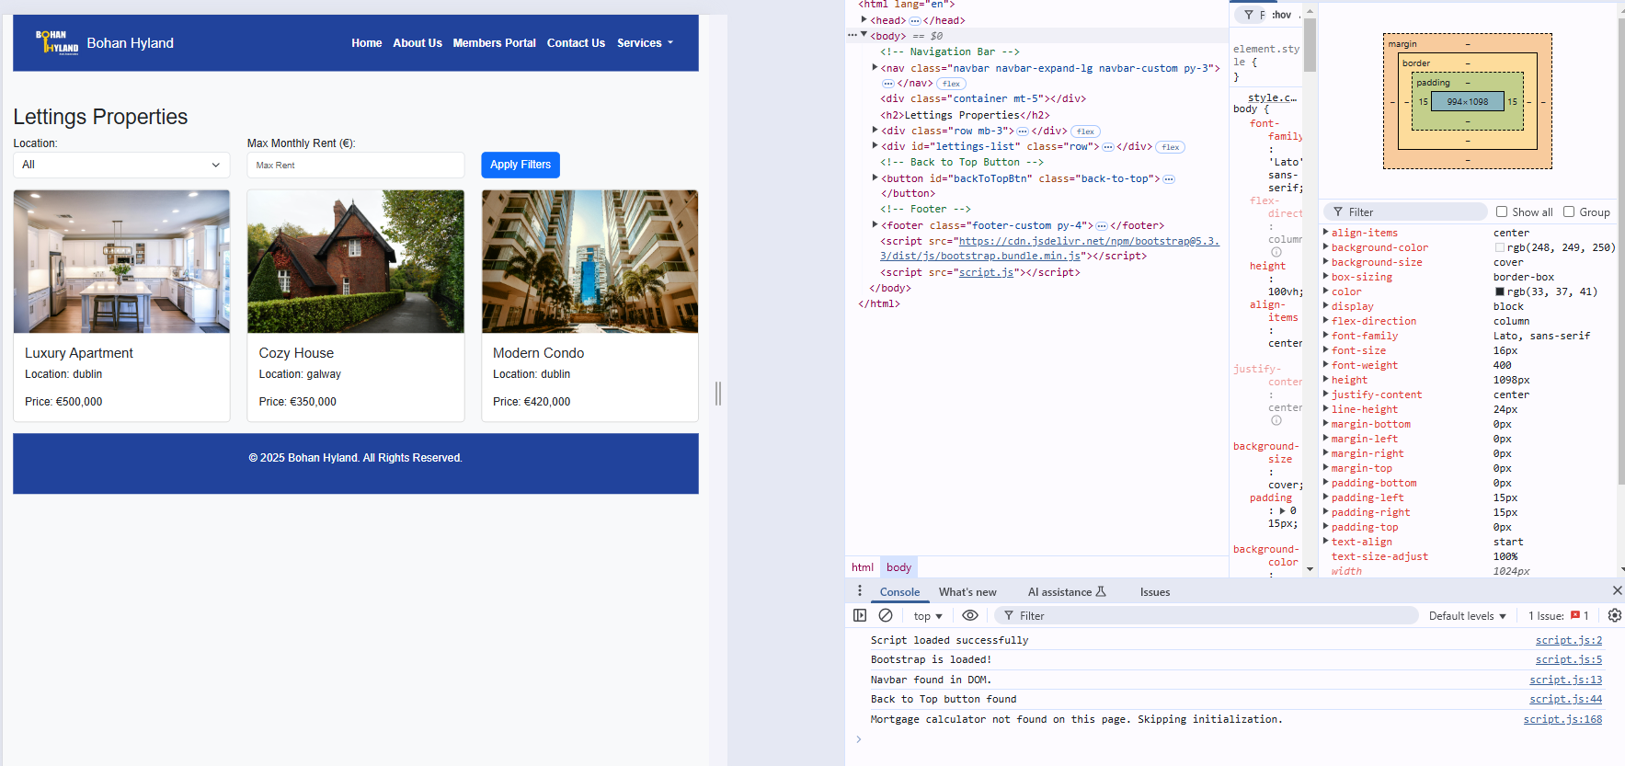

References:

<https://www.youtube.com/watch?v=eow125xV5-c>

<https://www.youtube.com/watch?v=EQrUGEvnCzY&t=52s>

<https://www.youtube.com/watch?v=Wqu-d_b3K-0>

https://youtu.be/MCRV9ajSfoc?si=S4Lm3sc5UwYfcVz2

<https://getbootstrap.com/>

<https://getbootstrap.com/docs/5.3/components/modal/>

<https://getbootstrap.com/docs/5.3/forms/form-control/>

https://getbootstrap.com/docs/5.3/utilities/text/

login without database: <https://chatgpt.com/share/67992455-37ac-8006-ac73-39a001022470>

How to add the regex to accept letters only: <https://chatgpt.com/share/6796609f-7930-8006-b36b-1108c31ef3cc>

Back to the top icon: <https://www.freepik.com/icon/back-top_7604589>

How to build a dynamic search, used to filter and sorting properties: <https://medium.com/%40AlexanderObregon/how-to-build-a-dynamic-search-feature-with-javascript-filters-464b97038be1>

For images: <https://www.pexels.com/> <https://unsplash.com/>

Mortgage calculator: <https://dev.to/bosspetta/mortgage-loan-calculator-with-javascript-2la7>

Form validation: https://developer.mozilla.org/en-US/docs/Learn_web_development/Extensions/Forms/Form_validation

Chat GPT help to make the background.jpg fit within the mortgage form: <https://chatgpt.com/share/679fd3c6-9544-8006-be35-bf4596804067>

<https://www.w3schools.com/HOWTO/howto_html_favicon.asp>

Forms: <https://getbootstrap.com/docs/5.3/forms/layout/#forms>

<https://medium.com/%40AlexanderObregon/how-to-build-a-dynamic-search-feature-with-javascript-filters-464b97038be1>